Department of Computer Science

Lab Manual

of

MACHINE LEARNING

MCA521-4

Class Name: IV MCA

Master of Computer Application

2026

Prepared by: Verified by:
Dr. Rupali Sunil Wagh
Dr. Helen K Joy
Dr. Shivangi Singh
Slaven Derick Pais
2547249

Department Overview
Department of Computer Science of CHRIST (Deemed to be University) strives to shape outstanding computer professionals with ethical and human values to reshape nation’s destiny. The training imparted aims to prepare young minds for the challenging opportunities in the IT industry with a global awareness rooted in the Indian soil, nourished and supported by experts in the field.

Vision
The Department of Computer Science endeavours to imbibe the vision of the University “Excellence and Service”. The department is committed to this philosophy which pervades every aspect and functioning of the department.

Mission
“To develop IT professionals with ethical and human values”. To accomplish our mission, the department encourages students to apply their acquired knowledge and skills towards professional achievements in their career. The department also moulds the students to be socially responsible and ethically sound.

Introduction to the Programme
Master of Computer Applications (MCA) is a post-graduate programme of CHRIST (Deemed to be University) and approved by the All India Council of Technical Education (AICTE). It is a two-year programme spread over six trimesters to bridge the chasm between computer studies and applications, bringing within reach of enthusiastic youngsters an excellent group of experienced and dedicated staff and experts, and an enviable infrastructure. MCA at CHRIST (Deemed to be University) strives to shape outstanding computer professionals with ethical and human values to reshape the nation’s destiny. The training programme aims to prepare young minds for challenging opportunities in the IT industry with a global awareness rooted in the Indian soil, nourished and supported by experts in the field. The Department is committed to the motto “Excellence and Service,” and this philosophy pervades every aspect of its functioning.

Programme Objective
This programme is conceptualised and designed based on the strong commitment of the
department to provide better quality education to the students. The principal objectives of this
course are to:
● Heighten technological awareness
● Train future industry specialists
● Encourage effective software development
● Provide research training
● Involve students in innovative research
● Produce graduates with a two-year professional education in Computer Science with
technical, professional, and communications skills.

Ethics and Human Values
1. Only proprietary or open-source software would be used for academic teaching and
learning purposes.
2. Copying of programs from the internet, friends or from other sources is strictly
discouraged since it impairs development of programming skills.
3. Unique Practical (Domain based) exercises ensure that the students don’t get involved in
code plagiarism.
4. Projects undertaken by students during the course are done in teams to improve
collaborative work and synergy between team members.
5. Projects involve modularization which initiates students to take individual responsibility
for common goals.
6. Passion for excellence is promoted among the students, be it in software development or
project documentation.
7. Giving due credit to sources during the seminar and research assignment is promoted
among the students
8. The course and its design enforce the practice of good referencing technique to improve
the sense of integrity.
9. Courses involving group discussions and debates on ethical practices and human values
are designed to sensitize the students in dealing with customers and members within the
Organization.

Programme Outcomes:
P01: Foundation Knowledge: Apply knowledge of mathematics, programming logic, and
coding fundamentals for solution architecture and problem-solving.
P02: Problem Analysis: Identify, review, formulate, and analyse problems primarily focussing on customer requirements using critical thinking frameworks.
P03: Development of Solutions: Design, develop and investigate problems with as an
innovative approach for solutions incorporating ESG/SDG goals.
PO4: Modern Tool Usage: Select, adapt, and apply modern computational tools such as the
development of algorithms with an understanding of the limitations including human biases.
P05: Individual and Teamwork: Function and communicate effectively as an individual or a
team leader in diverse and multidisciplinary groups. Use methodologies such as agile.
P06: Project Management and Finance: Use the principles of project management such as
scheduling, and work breakdown structure and be conversant with the principles of Finance for profitable project management.
P07: Ethics: Commit to professional ethics in managing software projects with financial aspects.
Learn to use new technologies for cyber security and insulate customers from malware
P08: Life-long learning: Change management skills and the ability to learn, keep up with
contemporary technologies and ways of working.

Programme Educational Objectives(PEO’s)
PEO1: Develop innovative and effective software solutions through research that addresses
real-world challenges, grounded in a commitment to continuous learning and adaptability.
PEO2: Advance the knowledge and practices in the field of computer applications through
lifelong learning and rigorous research, supporting professional growth and academic excellence.
PEO3: Exhibit ethical leadership, social responsibility to contribute and enhance community
well-being by innovating solutions.
MCA521-4 – MACHINE LEARNING
Course Name: MACHINE LEARNING Code: MCA521-4
Total Hours: 75
L + P + T: 3 + 4 + 0
Max Marks: 100
Credits: 4
Course Type: Core Course
Course Category: Theo&Prac
Course Description
Machine Learning is a key area in computer applications that focuses on building models capable of making predictions or informed decisions based on data. A strong understanding of machine learning enables students to analyze and interpret complex datasets, develop predictive models, and extract meaningful insights. This course covers a wide range of machine learning concepts and techniques, including supervised and unsupervised learning. It provides a solid theoretical foundation while emphasizing practical, hands-on experience with algorithms and real-world data. The course equips students with the knowledge and skills required to apply machine learning techniques across various domains using modern tools and methodologies.
Course Objectives
This course enables students to understand the fundamental concepts of Machine Learning, including its core principles, terminology, and methodologies. Students will learn to differentiate between various types of learning algorithms such as supervised, unsupervised, and reinforcement learning, and recognize their appropriate applications.
Course Outcomes
After successful completion of the course, students will be able to:
● Explain the fundamental principles and scope of Machine Learning
● Implement modelling practices in machine learning for better generalisation
● Interpret predictive modelling results and performance of supervised machine learning techniques
● Assess the outcomes and effects of unsupervised machine learning processes
● Deploy robust machine learning models for interdisciplinary applications

Unit-1: INTRODUCTION TO MACHINE LEARNING Teaching Hours: 15 Hours
Introduction to AI – Knowledge Representation – Data – Representation of Data, Data Processing, Data Storage, Data Processing, Types of Data – Exploratory Data Analysis, Visualisations and Interpretation, Outliers
Machine Learning: Definition, Objectives, Components, Features, Applications – Traditional Programming v/s Machine Learning, Types of Machine Learning – Predictive Models, Statistical Inferences – Applications of Machine Learning
Challenges in ML: Insufficient Quantity of Data, Non-representative and Poor-Quality Data, Irrelevant Features, Estimation Estimation, Reducing Human Biases in Model Building, Ethical Use of Technology
Lab Exercises:
1. Data Preprocessing and visualisation
2. Data exploration and inferences

Unit-2: PROCESSES IN MACHINE LEARNING Teaching Hours: 15 Hours
Data Preparation and Model Selection: Effect of Data Preparation: Encoding, Nominal and Ordinal Representation, Feature Transformation and Feature Engineering, Generalisation, Normalisation, Sampling, Using Saved Weights, Model Selection Strategies: Overfitting, Underfitting, Bias-Variance Trade-off, Testing and Validation: Performance measures - Confusion matrix, Precision-Recall Trade off, F1 Score, ROC Curve, AUC, Error Analysis, Model Parameters, Hyperparameters, Hyperparameter Tuning, Cross Validation, Decision Functions: Introduction to Supervised Machine Learning Methods, Decision Functions, Decision Thresholds, Distance Measures, Hyperplanes, Regression & Classification Problems, Loss and Cost Functions, Linear Regression using OLS, Multi-class vs Multi-label, KNN Classification
Lab Exercises:
3. Saving weights of a generalised model.
4. Regression and Classification Evaluation Metrics: Illustration through Linear Regression and KNN Classification

Unit-3: SUPERVISED LEARNING ALGORITHMS Teaching Hours: 15 Hours
Learning through Optimisation: Gradient Descent, Linear Regression, Logistic Regression Computational Learning: Decision Trees, Naive-bayes classification, Support Vector Machines, Ensemble Learners: Learning, Voting, Bagging, Stacking, Boosting, Random Forests, GridSearchCV
Lab Exercises:

5. Regression through Gradient Descent
6. Comparison of Different Classifiers
7. Illustration of Ensemble Learning Methods

Unit-4: UNSUPERVISED LEARNING AND DIMENSIONALITY REDUCTION Teaching Hours: 15 Hours
Introduction: Types of Unsupervised Learning, Challenges in Unsupervised Learning, Concept of Cost Functions in Unsupervised Learning, Clustering Methods: Distance based, Centroid Based, Elbow method to find Optimal Number of Clusters, Silhouette Method, K-Means Clustering, Hierarchical Clustering: Agglomerative and Bottom Up, Applying Supervised Learning after Clustering, Dimensionality Reduction Methods: Principal Component Analysis (PCA), Linear Discriminant Analysis (LDA)
Lab Exercises:
8. KMeans and Elbow Methods
9. Hierarchical Clustering and Dendrograms
10. Dimensionality Reduction
11. Image Compression using Dimensionality Reduction.

Unit-5 Teaching Hours: 15 Hours
MACHINE LEARNING IN REAL-WORLD
Emerging Techniques: Role of ML in attaining Sustainable Development Goals, Time Series Preprocessing, Blackbox Methods: Neural Networks & Deep Learning, Reinforcement Learning/QLearning, Self Supervised Learning, Quantum Machine Learning, Keras and Tensorflow for designing Multi Layer Perceptron. Case Studies: CNN, RNN, Advances in Deep Learning, Natural Language Processing, Real Time Systems, Computer Vision, Robotics, Expert Systems, Generative Networks, Large Language Models. Model Deployment: Model Deployment: Connecting Models to User Interface, Deployment of ML Models.
Lab Exercises:
12. Training a Multi-layer perceptron
13. Deploying Trained ML-models

Text and Reference Books
[1] Campesato, O. (2020). Artificial Intelligence, Machine Learning and Deep Learning. Mercury Learning and Information.
[2] Andreas C. Müller and Sarah Guido (2017), “Introduction to Machine Learning with Python A Guide For Data Scientists” O’Reilly book
[3] Ethem Alpaydin (2005), “Introduction to Machine Learning”, Prentice Hall of India
[4] Max Kuhn and Kjell Johnson (2018), “Applied Predictive Modelling”, Springer

Essential Reading
[1] Stuart Russell and Peter Norvig(2020), “Artificial Intelligence: A Modern Approach” (4th Edition), Pearson
[2] Aurelien Geron(2019), “Hands on Machine Learning with Scikit-learn, Keras and Tensorflow”, 2nd Edition, O’Reilly Books
[3] Kevin P. Murphy(2012), “Machine Learning: A Probabilistic Perspective”, MIT Press
[4] Hastie, Tibshirani, Friedman(2008), “The Elements of Statistical Learning” (2nd ed), Springer
[5] Ian Goodfellow, Aaron Courville, Yoshua Bengio (2019), “Deep Learning (Adaptive Computation And Machine Learning Series)”, MIT Press
Additional Information (Web Resources):
1. Andrew Ng, Deeplearning.ai, Machine Learning Specialisation, offered through Coursera: https://www.deeplearning.ai/courses/machine-learning-specialization/

Evaluation Pattern: CIA - 50% ESE - 50%

LIST OF PROGRAMS

MSCAIML
Sl.no | Title of lab Experiment | Page number | RBT | CO
1 | Data Preprocessing and visualization |  | L3 | CO1,3
2 | Data exploration and inferences |  | L3 | CO2,3
3 |  |  | L3 | CO3
4 |  |  | L3 | CO3
5 |  |  | L3 | CO3
6 |  |  | L3 | CO3,4
7 |  |  | L4 | CO3
8 |  |  | L3 | CO3
9 |  |  | L3 | CO4
10 |  |  | L5 | CO4

Evaluation Rubrics:
Evaluation Rubrics for each program would be
EVALUATION RUBRICS
(R1) Concept Clarity (Viva) - 3 M
(R2) Code Execution - 3M
(R3) Complexity Addition (Self Learning) -2 M
(R4) Timely Submission - 2 M

Submission Guidelines:
- Make a copy of the lab manual template with your <name_reg:no_subject name >,

- Copy the given question and the answer (lab code) with results, followed by the conclusion of that lab. Title the lab as lab number.
- Keep updating your lab manual and show the lab manual of that particular lab for evaluation.
- Create a Git Repository in your profile <ML lab-reg no> . Follow a different branch for each lab <Lab 1, Lab 2…>, and push the code to Git. The link should be provided in Google Classroom along with the PDF of the lab manual.
- Upload the PDF to Google Classroom before the deadline.

Lab Exercise 3

Student Survey: Simple Linear Regression using Scikit Learn, OLS, and Parameter Saving

Aim
To collect real-world student survey data using Google Forms, preprocess and clean the dataset, perform Simple Linear Regression using Scikit-learn, manually compute the regression equation using Ordinary Least Squares (OLS) formulas, compare both approaches, and save the learned model parameters.
Instructions
- During the first 15 minutes of the lab session, fill out the Google Form shared, link :
MCA-B
https://docs.google.com/forms/d/e/1FAIpQLSdR13N42Eh2Lz7U7QYkw9bp-G03puOGKROVQz4fzUDGdF1g8A/viewform?usp=publish-editor
MCA-A
https://docs.google.com/forms/d/1cMs0pElLKDkqJEUt2TYRdZg3rJz7-aTelD6uT3EW8VA/edit?ts=6a2ecba6
- Ensure that responses are collected from your classmates.
- Export the responses into CSV format.
- Use the collected dataset for all further analysis
Suggested dataset name:
student_survey.csv
Problem Statement
Using the dataset collected from the class survey form, perform Simple Linear Regression analysis to determine whether:
- CIA percentage can predict GPA
- Attendance percentage can predict GPA
You are required to perform regression in two different ways:
- Using Scikit learn LinearRegression
- Manually using the mathematical equations of slope and intercept derived from Ordinary Least Squares (OLS)
Finally, compare the outputs obtained from both methods and save the learned model parameters.

Refer this for getting and understanding : https://colab.research.google.com/drive/1No__uEMN0sq8y2oqGvRgL9FKMGAp7BxX#scrollTo=a7bfa6e8
Tasks to Perform

Part A: Data Collection and Preprocessing
Perform the following steps:
- Load the dataset using Pandas
- Display the first 5 rows
- Check dataset dimensions
- Identify missing values
- Remove or handle null values
- Convert required columns into numerical datatype
- Remove duplicate records if present
- Generate statistical summary
- Select appropriate dependent and independent variables

Regression Experiments: Experiment 1
Independent Variable (X):
CIA Percentage
Dependent Variable (Y):
GPA

Experiment 2
Independent Variable (X):
Attendance Percentage
Dependent Variable (Y):
GPA
Part B: Simple Linear Regression using Scikit-learn
Perform the following:
- Split the dataset into training and testing sets
- Train the model using LinearRegression from Scikit learn
- Obtain:
  - Slope
  - Intercept
- Predict output values using the trained mod
Part C: Manual Computation using Ordinary Least Squares (OLS)
Using the same dataset, manually compute the regression line using the OLS formulas given below.
Refer : 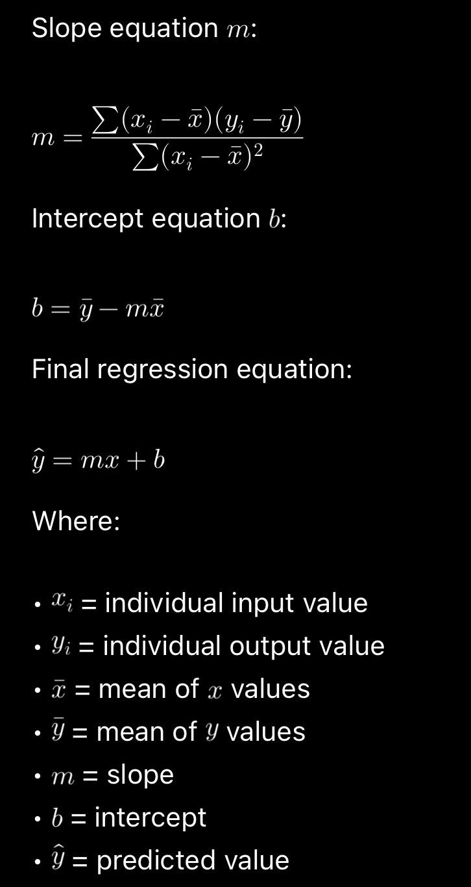Manual Regression Equation
Construct the regression equation manually using the computed slope and intercept values.
Comparison Task
Compare the following:
- Predictions from Scikit learn
- Predictions from manually computed OLS equation
- Difference between both outputs
Provide observations regarding whether both methods produce similar results.

Parameter Saving Task
Save the parameters learned by the model using Pickle.
The following parameters must be saved:
- Slope
- Intercept
Suggested file name:
linear_regression_weights.pkl
Demonstrate:
- Saving parameters into Pickle file
- Loading the Pickle file
- Using loaded parameters for prediction
Expected Output
Submit the following:
- CSV dataset
- Data preprocessing notebook
- Scikit learn regression implementation
- Manual OLS calculation( self study )
- Comparison of both approaches
- Pickle file containing saved parameters
- Final observations and inference

Part A: Data Collection and Preprocessing
Perform the following steps:
- Load the dataset using Pandas
- Display the first 5 rows
- Check dataset dimensions
- Identify missing values
- Remove or handle null values
- Convert required columns into numerical datatype
- Remove duplicate records if present
- Generate statistical summary
- Select appropriate dependent and independent variables

Student Survey: Simple Linear Regression using Scikit Learn, OLS, and Parameter Saving - Machine Learning - Lab 3

Data Preprocessing, Visualisation & Exploratory Data Analysis

Students Report

Part A: Data Collection and Preprocessing

Tasks to Perform

Load CSV
import pandas as pd

student_data = pd.read_csv("student_survey.csv")

student_data.head()

Step 2 — Rename Long Columns

Use Shorter Name
student_data = student_data.rename(columns={
'Your CIA % of last semester': 'CIA',
'Your GPA of last semester': 'GPA',
'Your maximum attendance % till last semester': 'Attendance',
'Job role that you are interested in': 'Role'
})

Step 3 — Keep Only Needed Columns
student_data = student_data[['CIA', 'Attendance', 'GPA', 'Role']]
student_data.head()

 | CIA | Attendance | GPA | Role
0 | 69 | 98 | 3.40 | Software Development Engineer (SDE)
1 | 75 | 95 | 3.69 | Software Development Engineer (SDE)
2 | 82 | 95 | 3.41 | Full Stack Developer
3 | 91 | 92 | 3.60 | Full Stack Developer
4 | 70 | 93 | 3.54 | Software Development Engineer (SDE)

Step 4 — Checking Missing Values
print(student_data.isnull().sum())

CIA 0
Attendance 0
GPA 0
Role 0
dtype: int64

Step 5 — Remove % Symbols
student_data['CIA'] = student_data['CIA'].astype(str).str.replace('%', '', regex=False)
student_data['Attendance'] = student_data['Attendance'].astype(str).str.replace('%', '', regex=False)

After Removing
student_data.head()

 | CIA | Attendance | GPA | Role
0 | 69 | 98 | 3.40 | Software Development Engineer (SDE)
1 | 75 | 95 | 3.69 | Software Development Engineer (SDE)
2 | 82 | 95 | 3.41 | Full Stack Developer
3 | 91 | 92 | 3.60 | Full Stack Developer
4 | 70 | 93 | 3.54 | Software Development Engineer (SDE)

Step 6 — Convert to Numeric
student_data['CIA'] = pd.to_numeric(student_data['CIA'], errors='coerce')
student_data['Attendance'] = pd.to_numeric(student_data['Attendance'], errors='coerce')
student_data['GPA'] = pd.to_numeric(student_data['GPA'], errors='coerce')

Checking
student_data.dtypes

CIA float64
Attendance float64
GPA float64
Role object
dtype: object
student_data

 | CIA | Attendance | GPA | Role
0 | 69.00 | 98.00 | 3.40 | Software Development Engineer (SDE)
1 | 75.00 | 95.00 | 3.69 | Software Development Engineer (SDE)
2 | 82.00 | 95.00 | 3.41 | Full Stack Developer
3 | 91.00 | 92.00 | 3.60 | Full Stack Developer
4 | 70.00 | 93.00 | 3.54 | Software Development Engineer (SDE)
5 | 75.00 | 98.00 | 3.67 | Machine Learning Engineer
6 | 74.00 | 94.00 | 3.40 | Full Stack Developer
7 | 68.00 | 85.00 | 3.40 | Cyber Security Analyst
8 | 73.00 | 90.00 | 3.60 | Software Development Engineer (SDE)
9 | 79.00 | 93.00 | 3.73 | Software Development Engineer (SDE)
10 | 72.00 | 95.00 | 3.54 | Machine Learning Engineer
11 | 80.00 | 95.00 | 3.00 | Cyber Security Analyst
12 | 78.00 | 95.00 | 3.32 | Data Scientist
13 | 7.00 | 85.00 | 8.00 | Software Development Engineer (SDE)
14 | 70.00 | 100.00 | 3.49 | Data Scientist
15 | 60.00 | 85.00 | 3.00 | Data Scientist
16 | 68.00 | 88.00 | 3.14 | Full Stack Developer
17 | 71.00 | 91.00 | 3.40 | Full Stack Developer
18 | 64.00 | 100.00 | 3.11 | Full Stack Developer
19 | 71.78 | 96.54 | 3.49 | Cyber Security Analyst
20 | 70.00 | 95.00 | 3.34 | Full Stack Developer
21 | 63.00 | 90.00 | 3.40 | Cloud Architect
22 | 76.00 | 95.00 | 3.69 | Software Development Engineer (SDE)
23 | 83.00 | 98.00 | 3.90 | Software Development Engineer (SDE)
24 | 80.00 | 94.70 | 3.37 | Machine Learning Engineer
25 | 72.00 | 93.00 | 3.55 | Full Stack Developer
26 | 70.00 | 96.00 | 3.40 | Full Stack Developer
27 | 70.00 | 93.00 | 3.00 | UX/UI Designer
28 | 71.00 | 99.00 | 3.33 | Consultant
29 | 77.00 | 90.00 | 3.30 | Cloud Architect
30 | 80.00 | 100.00 | 3.79 | Cyber Security Analyst
31 | 80.00 | 92.00 | 3.12 | Software Development Engineer (SDE)
32 | 80.00 | 95.00 | 3.60 | Data Scientist
33 | 70.00 | 94.00 | 3.40 | Data Scientist
34 | 85.00 | 89.00 | 3.14 | Cyber Security Analyst
35 | 71.00 | 88.00 | 3.40 | Data Scientist
36 | 68.00 | 97.00 | 3.40 | Full Stack Developer
37 | 67.00 | 95.00 | 3.46 | UX/UI Designer
38 | 72.00 | 100.00 | 3.40 | Data Scientist
39 | 65.00 | 89.00 | 3.30 | Data Scientist
40 | 76.00 | 96.00 | 3.60 | Full Stack Developer
41 | 75.20 | 96.00 | 3.54 | Machine Learning Engineer
42 | 69.78 | 92.00 | 3.30 | Full Stack Developer
43 | 71.11 | 93.00 | 3.37 | Data Scientist
44 | 79.56 | 95.00 | 3.60 | Machine Learning Engineer
45 | 75.00 | 95.00 | 3.66 | Full Stack Developer
46 | 70.00 | 97.00 | 3.69 | Full Stack Developer
47 | 62.00 | 97.00 | 3.00 | Data Scientist
48 | 66.00 | 90.00 | 2.74 | Full Stack Developer
49 | 63.00 | 94.00 | 3.13 | Software Development Engineer (SDE)

Step 7 — Remove Duplicates
print("Duplicates:", student_data.duplicated().sum())

Duplicates: 0

Step 8 — Apply Logical Constraints

Before Cleaning
print("Before cleaning:", student_data.shape)

Before cleaning: (50, 4)

CIA Range
student_data = student_data[(student_data['CIA'] >= 0) & (student_data['CIA'] <= 100)]

Attendance Range
student_data = student_data[(student_data['Attendance'] >= 0) & (student_data['Attendance'] <= 100)]

GPA Range
student_data = student_data[(student_data['GPA'] >= 0) & (student_data['GPA'] <= 10)]

After Cleaning
print("After cleaning:", student_data.shape)

After cleaning: (50, 4)

Step 9 — Outlier Check

Cia Outlier
Q1 = student_data['CIA'].quantile(0.25)
Q3 = student_data['CIA'].quantile(0.75)
IQR = Q3 - Q1

lower = Q1 - 1.5 * IQR
upper = Q3 + 1.5 * IQR

cia_outliers = student_data[(student_data['CIA'] < lower) | (student_data['CIA'] > upper)]

print("CIA Outliers:")
print(cia_outliers)

CIA Outliers:
CIA Attendance GPA Role
3 91.0 92.0 3.6 Full Stack Developer
13 7.0 85.0 8.0 Software Development Engineer (SDE)

Attendance Outlier
Q1 = student_data['Attendance'].quantile(0.25)
Q3 = student_data['Attendance'].quantile(0.75)
IQR = Q3 - Q1

lower = Q1 - 1.5 * IQR
upper = Q3 + 1.5 * IQR

attendance_outliers = student_data[(student_data['Attendance'] < lower) | (student_data['Attendance'] > upper)]

print("Attendance Outliers:")
print(attendance_outliers)

Attendance Outliers:
CIA Attendance GPA Role
7 68.0 85.0 3.4 Cyber Security Analyst
13 7.0 85.0 8.0 Software Development Engineer (SDE)
15 60.0 85.0 3.0 Data Scientist

GPA Outlier
Q1 = student_data['GPA'].quantile(0.25)
Q3 = student_data['GPA'].quantile(0.75)
IQR = Q3 - Q1

lower = Q1 - 1.5 * IQR
upper = Q3 + 1.5 * IQR

gpa_outliers = student_data[(student_data['GPA'] < lower) | (student_data['GPA'] > upper)]

print("GPA Outliers:")
print(gpa_outliers)

GPA Outliers:
CIA Attendance GPA Role
13 7.0 85.0 8.00 Software Development Engineer (SDE)
48 66.0 90.0 2.74 Full Stack Developer

Step 10 — Treating Outlier

CIA Typo
student_data.loc[student_data['CIA'] == 7, 'CIA'] = 70

student_data

 | CIA | Attendance | GPA | Role
0 | 69.00 | 98.00 | 3.40 | Software Development Engineer (SDE)
1 | 75.00 | 95.00 | 3.69 | Software Development Engineer (SDE)
2 | 82.00 | 95.00 | 3.41 | Full Stack Developer
3 | 91.00 | 92.00 | 3.60 | Full Stack Developer
4 | 70.00 | 93.00 | 3.54 | Software Development Engineer (SDE)
5 | 75.00 | 98.00 | 3.67 | Machine Learning Engineer
6 | 74.00 | 94.00 | 3.40 | Full Stack Developer
7 | 68.00 | 85.00 | 3.40 | Cyber Security Analyst
8 | 73.00 | 90.00 | 3.60 | Software Development Engineer (SDE)
9 | 79.00 | 93.00 | 3.73 | Software Development Engineer (SDE)
10 | 72.00 | 95.00 | 3.54 | Machine Learning Engineer
11 | 80.00 | 95.00 | 3.00 | Cyber Security Analyst
12 | 78.00 | 95.00 | 3.32 | Data Scientist
13 | 70.00 | 85.00 | 8.00 | Software Development Engineer (SDE)
14 | 70.00 | 100.00 | 3.49 | Data Scientist
15 | 60.00 | 85.00 | 3.00 | Data Scientist
16 | 68.00 | 88.00 | 3.14 | Full Stack Developer
17 | 71.00 | 91.00 | 3.40 | Full Stack Developer
18 | 64.00 | 100.00 | 3.11 | Full Stack Developer
19 | 71.78 | 96.54 | 3.49 | Cyber Security Analyst
20 | 70.00 | 95.00 | 3.34 | Full Stack Developer
21 | 63.00 | 90.00 | 3.40 | Cloud Architect
22 | 76.00 | 95.00 | 3.69 | Software Development Engineer (SDE)
23 | 83.00 | 98.00 | 3.90 | Software Development Engineer (SDE)
24 | 80.00 | 94.70 | 3.37 | Machine Learning Engineer
25 | 72.00 | 93.00 | 3.55 | Full Stack Developer
26 | 70.00 | 96.00 | 3.40 | Full Stack Developer
27 | 70.00 | 93.00 | 3.00 | UX/UI Designer
28 | 71.00 | 99.00 | 3.33 | Consultant
29 | 77.00 | 90.00 | 3.30 | Cloud Architect
30 | 80.00 | 100.00 | 3.79 | Cyber Security Analyst
31 | 80.00 | 92.00 | 3.12 | Software Development Engineer (SDE)
32 | 80.00 | 95.00 | 3.60 | Data Scientist
33 | 70.00 | 94.00 | 3.40 | Data Scientist
34 | 85.00 | 89.00 | 3.14 | Cyber Security Analyst
35 | 71.00 | 88.00 | 3.40 | Data Scientist
36 | 68.00 | 97.00 | 3.40 | Full Stack Developer
37 | 67.00 | 95.00 | 3.46 | UX/UI Designer
38 | 72.00 | 100.00 | 3.40 | Data Scientist
39 | 65.00 | 89.00 | 3.30 | Data Scientist
40 | 76.00 | 96.00 | 3.60 | Full Stack Developer
41 | 75.20 | 96.00 | 3.54 | Machine Learning Engineer
42 | 69.78 | 92.00 | 3.30 | Full Stack Developer
43 | 71.11 | 93.00 | 3.37 | Data Scientist
44 | 79.56 | 95.00 | 3.60 | Machine Learning Engineer
45 | 75.00 | 95.00 | 3.66 | Full Stack Developer
46 | 70.00 | 97.00 | 3.69 | Full Stack Developer
47 | 62.00 | 97.00 | 3.00 | Data Scientist
48 | 66.00 | 90.00 | 2.74 | Full Stack Developer
49 | 63.00 | 94.00 | 3.13 | Software Development Engineer (SDE)

GPA > 4
student_data[student_data['GPA'] > 4]

 | CIA | Attendance | GPA | Role
13 | 70.0 | 85.0 | 8.0 | Software Development Engineer (SDE)
student_data.loc[
(student_data['GPA'] > 4) & (student_data['GPA'] <= 10),
'GPA'
] = (
student_data.loc[
(student_data['GPA'] > 4) & (student_data['GPA'] <= 10),
'GPA'
] / 10
) * 4

student_data[student_data['GPA'] > 4]

 | CIA | Attendance | GPA | Role

Final Data After Cleaning
student_data

 | CIA | Attendance | GPA | Role
0 | 69.00 | 98.00 | 3.40 | Software Development Engineer (SDE)
1 | 75.00 | 95.00 | 3.69 | Software Development Engineer (SDE)
2 | 82.00 | 95.00 | 3.41 | Full Stack Developer
3 | 91.00 | 92.00 | 3.60 | Full Stack Developer
4 | 70.00 | 93.00 | 3.54 | Software Development Engineer (SDE)
5 | 75.00 | 98.00 | 3.67 | Machine Learning Engineer
6 | 74.00 | 94.00 | 3.40 | Full Stack Developer
7 | 68.00 | 85.00 | 3.40 | Cyber Security Analyst
8 | 73.00 | 90.00 | 3.60 | Software Development Engineer (SDE)
9 | 79.00 | 93.00 | 3.73 | Software Development Engineer (SDE)
10 | 72.00 | 95.00 | 3.54 | Machine Learning Engineer
11 | 80.00 | 95.00 | 3.00 | Cyber Security Analyst
12 | 78.00 | 95.00 | 3.32 | Data Scientist
13 | 70.00 | 85.00 | 3.20 | Software Development Engineer (SDE)
14 | 70.00 | 100.00 | 3.49 | Data Scientist
15 | 60.00 | 85.00 | 3.00 | Data Scientist
16 | 68.00 | 88.00 | 3.14 | Full Stack Developer
17 | 71.00 | 91.00 | 3.40 | Full Stack Developer
18 | 64.00 | 100.00 | 3.11 | Full Stack Developer
19 | 71.78 | 96.54 | 3.49 | Cyber Security Analyst
20 | 70.00 | 95.00 | 3.34 | Full Stack Developer
21 | 63.00 | 90.00 | 3.40 | Cloud Architect
22 | 76.00 | 95.00 | 3.69 | Software Development Engineer (SDE)
23 | 83.00 | 98.00 | 3.90 | Software Development Engineer (SDE)
24 | 80.00 | 94.70 | 3.37 | Machine Learning Engineer
25 | 72.00 | 93.00 | 3.55 | Full Stack Developer
26 | 70.00 | 96.00 | 3.40 | Full Stack Developer
27 | 70.00 | 93.00 | 3.00 | UX/UI Designer
28 | 71.00 | 99.00 | 3.33 | Consultant
29 | 77.00 | 90.00 | 3.30 | Cloud Architect
30 | 80.00 | 100.00 | 3.79 | Cyber Security Analyst
31 | 80.00 | 92.00 | 3.12 | Software Development Engineer (SDE)
32 | 80.00 | 95.00 | 3.60 | Data Scientist
33 | 70.00 | 94.00 | 3.40 | Data Scientist
34 | 85.00 | 89.00 | 3.14 | Cyber Security Analyst
35 | 71.00 | 88.00 | 3.40 | Data Scientist
36 | 68.00 | 97.00 | 3.40 | Full Stack Developer
37 | 67.00 | 95.00 | 3.46 | UX/UI Designer
38 | 72.00 | 100.00 | 3.40 | Data Scientist
39 | 65.00 | 89.00 | 3.30 | Data Scientist
40 | 76.00 | 96.00 | 3.60 | Full Stack Developer
41 | 75.20 | 96.00 | 3.54 | Machine Learning Engineer
42 | 69.78 | 92.00 | 3.30 | Full Stack Developer
43 | 71.11 | 93.00 | 3.37 | Data Scientist
44 | 79.56 | 95.00 | 3.60 | Machine Learning Engineer
45 | 75.00 | 95.00 | 3.66 | Full Stack Developer
46 | 70.00 | 97.00 | 3.69 | Full Stack Developer
47 | 62.00 | 97.00 | 3.00 | Data Scientist
48 | 66.00 | 90.00 | 2.74 | Full Stack Developer
49 | 63.00 | 94.00 | 3.13 | Software Development Engineer (SDE)

Distribution of numeric data
import matplotlib.pyplot as plt

student_data[['CIA', 'Attendance', 'GPA']].hist(figsize=(10,5), bins=10)
plt.suptitle("Distribution of Numerical Features")
plt.show()

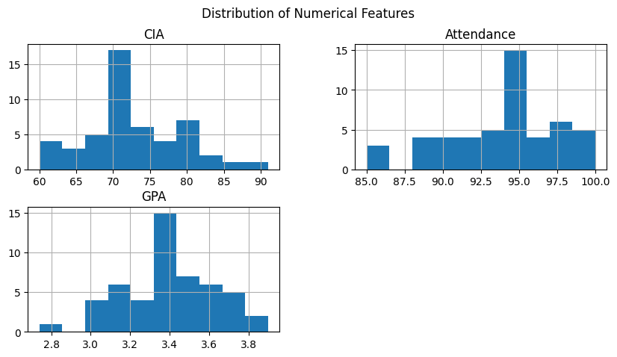

Box Plot for outliers
import matplotlib.pyplot as plt

plt.figure(figsize=(8,4))
student_data[['CIA', 'Attendance', 'GPA']].boxplot()
plt.title("Boxplot of Cleaned Numerical Features")
plt.show()

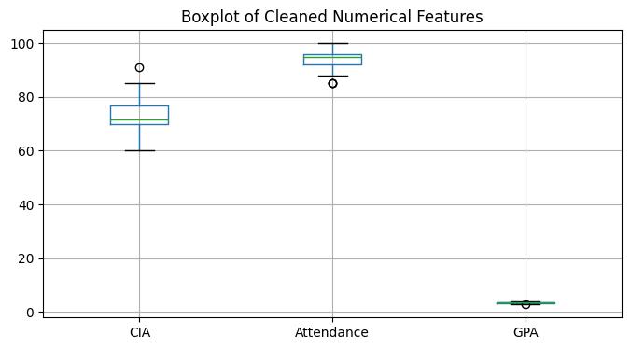

CIA vs GPA
plt.figure(figsize=(6,4))
plt.scatter(student_data['CIA'], student_data['GPA'])
plt.xlabel("CIA Percentage")
plt.ylabel("GPA")
plt.title("CIA vs GPA")
plt.show()

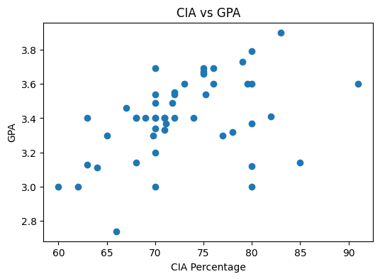

Attendance vs GPA
plt.figure(figsize=(6,4))
plt.scatter(student_data['Attendance'], student_data['GPA'])
plt.xlabel("Attendance Percentage")
plt.ylabel("GPA")
plt.title("Attendance vs GPA")
plt.show()

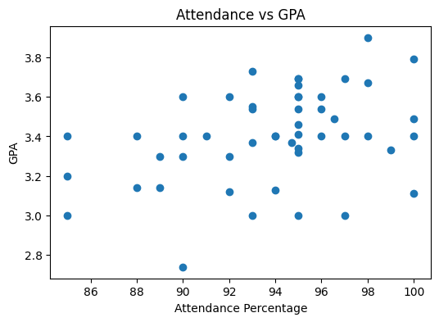

Correlation to see how strong the variables are related
import seaborn as sns
import matplotlib.pyplot as plt

corr = student_data[['CIA', 'Attendance', 'GPA']].corr()

sns.heatmap(corr, annot=True, cmap='Blues')
plt.title("Correlation Matrix")
plt.show()

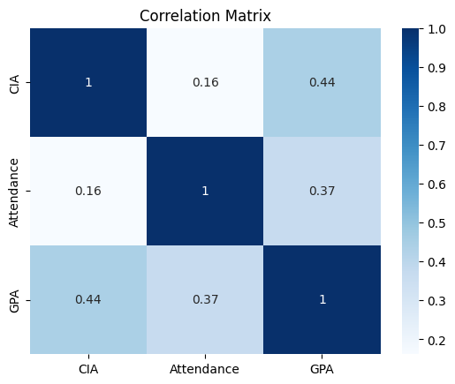

Part 2 Regression Experiments

Experiment 1

CIA and GPA
X1 = student_data[['CIA']]
y1 = student_data['GPA']

print(X1.shape)
print(y1.shape)

(50, 1)
(50,)

from sklearn.model_selection import train_test_split
from sklearn.linear_model import LinearRegression

X1_train, X1_test, y1_train, y1_test = train_test_split(
X1, y1, test_size=0.2, random_state=42
)

# Train model
cia_model = LinearRegression()
cia_model.fit(X1_train, y1_train)

# Model parameters
CIA_slope = cia_model.coef_[0]
CIA_intercept = cia_model.intercept_

print("Slope:", CIA_slope)
print("Intercept:", CIA_intercept)

# Predictions
cia_y_pred = cia_model.predict(X1_test)

# Compare actual vs predicted
comparison = pd.DataFrame({
'Actual GPA': y1_test.values,
'Predicted GPA': cia_y_pred
})

print("\nActual vs Predicted:")
print(comparison)

# Regression equation
print(f"\nRegression Equation: GPA = {CIA_slope:.4f}(CIA) + {CIA_intercept:.4f}")

# Visualization
plt.figure(figsize=(6,4))
plt.scatter(X1, y1)
plt.plot(X1, cia_model.predict(X1), linewidth=2)
plt.xlabel("CIA Percentage")
plt.ylabel("GPA")
plt.title("Linear Regression: CIA vs GPA")
plt.show()

Slope: 0.012783144582063033
Intercept: 2.4655814552535955

Actual vs Predicted:
Actual GPA Predicted GPA
0 3.20 3.360402
1 3.30 3.296486
2 3.79 3.488233
3 3.66 3.424317
4 3.40 3.373185
5 2.74 3.309269
6 3.40 3.360402
7 3.55 3.385968
8 3.60 3.488233
9 3.49 3.383156

Regression Equation: GPA = 0.0128(CIA) + 2.4656

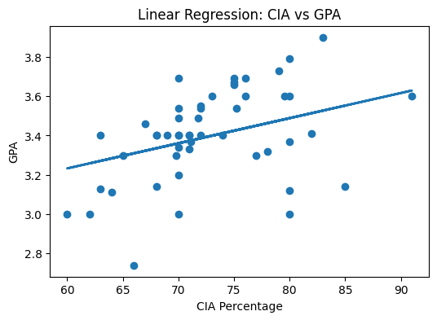
print("\nActual vs Predicted:")
print(comparison)

Actual vs Predicted:
Actual GPA Predicted GPA
0 3.20 3.360402
1 3.30 3.296486
2 3.79 3.488233
3 3.66 3.424317
4 3.40 3.373185
5 2.74 3.309269
6 3.40 3.360402
7 3.55 3.385968
8 3.60 3.488233
9 3.49 3.383156

print("Slope:", CIA_slope)
print("Intercept:", CIA_intercept)

Slope: 0.012783144582063033
Intercept: 2.4655814552535955

Experiment 2

Attendance and GPA
import pandas as pd
import matplotlib.pyplot as plt
from sklearn.model_selection import train_test_split
from sklearn.linear_model import LinearRegression

# Independent and dependent variables
X = student_data[['Attendance']]
y = student_data['GPA']

# Train-test split
X_train, X_test, y_train, y_test = train_test_split(
X, y, test_size=0.2, random_state=42
)

# Train model
attendance_model = LinearRegression()
attendance_model.fit(X_train, y_train)

# Model parameters
attendance_slope = attendance_model.coef_[0]
attendance_intercept = attendance_model.intercept_

print("Slope:", attendance_slope)
print("Intercept:", attendance_intercept)

# Predictions
attendance_y_pred = attendance_model.predict(X_test)

# Compare actual vs predicted
comparison = pd.DataFrame({
'Actual GPA': y_test.values,
'Predicted GPA': attendance_y_pred
})

print("\nActual vs Predicted:")
print(comparison)

# Regression equation
print(f"\nRegression Equation: GPA = {attendance_slope:.4f}(Attendance) + {attendance_intercept:.4f}")

# Visualization
plt.figure(figsize=(6,4))
plt.scatter(X, y)
plt.plot(X, attendance_model.predict(X), linewidth=2)
plt.xlabel("Attendance Percentage")
plt.ylabel("GPA")
plt.title("Linear Regression: Attendance vs GPA")
plt.show()

Slope: 0.015844580750996744
Intercept: 1.908332129243164

Actual vs Predicted:
Actual GPA Predicted GPA
0 3.20 3.255121
1 3.30 3.318500
2 3.79 3.492790
3 3.66 3.413567
4 3.40 3.350189
5 2.74 3.334344
6 3.40 3.429412
7 3.55 3.381878
8 3.60 3.413567
9 3.49 3.437968

Regression Equation: GPA = 0.0158(Attendance) + 1.9083

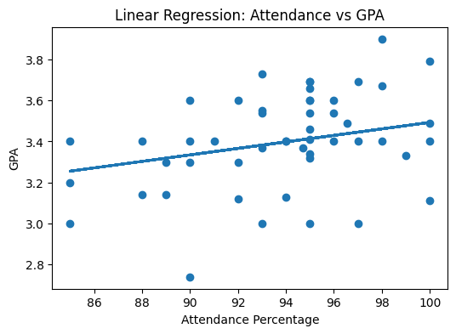
print("\nActual vs Predicted:")
print(comparison)

Actual vs Predicted:
Actual GPA Predicted GPA
0 3.20 3.255121
1 3.30 3.318500
2 3.79 3.492790
3 3.66 3.413567
4 3.40 3.350189
5 2.74 3.334344
6 3.40 3.429412
7 3.55 3.381878
8 3.60 3.413567
9 3.49 3.437968

print("Slope:", attendance_slope)
print("Intercept:", attendance_intercept)

Slope: 0.015844580750996744
Intercept: 1.908332129243164

Part 3 OLS Experiments

Experiment 1

CIA and GPA
import numpy as np
import pandas as pd

# Use SAME training data as sklearn

x = X1_train['CIA'].to_numpy()
y = y_train.to_numpy()

n = len(x)

# Calculate slope (m)
m = (
n * np.sum(x * y) - np.sum(x) * np.sum(y)
) / (
n * np.sum(x * x) - (np.sum(x) ** 2)
)

# Calculate intercept (b)
b = (
np.sum(y) - m * np.sum(x)
) / n

print("Manual OLS Slope:", m)
print("Manual OLS Intercept:", b)

# Regression Equation
print(f"\nRegression Equation: GPA = {m:.6f} * CIA + {b:.6f}")

# Predict on test data
manual_predictions = m * X1_test['CIA'].to_numpy() + b

# Compare predictions
comparison = pd.DataFrame({
"Actual GPA": y_test.values,
"Predicted GPA (Manual OLS)": manual_predictions
})

print("\nActual vs Predicted:")
print(comparison)

Manual OLS Slope: 0.012783144582062278
Manual OLS Intercept: 2.46558145525365

Regression Equation: GPA = 0.012783 * CIA + 2.465581

Actual vs Predicted:
Actual GPA Predicted GPA (Manual OLS)
0 3.20 3.360402
1 3.30 3.296486
2 3.79 3.488233
3 3.66 3.424317
4 3.40 3.373185
5 2.74 3.309269
6 3.40 3.360402
7 3.55 3.385968
8 3.60 3.488233
9 3.49 3.383156

Experiment 2

Attendance and GPA
import numpy as np
import pandas as pd

# Use SAME training data as sklearn
x = X_train['Attendance'].to_numpy()
y = y_train.to_numpy()

n = len(x)

# Compute slope
m = (
n * np.sum(x * y) - np.sum(x) * np.sum(y)
) / (
n * np.sum(x * x) - (np.sum(x) ** 2)
)

# Compute intercept
b = (np.sum(y) - m * np.sum(x)) / n

print("Manual OLS Slope:", m)
print("Manual OLS Intercept:", b)

print(f"\nRegression Equation: GPA = {m:.6f} * Attendance + {b:.6f}")

# Predict on test data
manual_predictions = m * X_test['Attendance'].to_numpy() + b

# Compare predictions
comparison = pd.DataFrame({
"Actual GPA": y_test.values,
"Predicted GPA (Manual OLS)": manual_predictions
})

print("\nActual vs Predicted:")
print(comparison)

Manual OLS Slope: 0.0158445807509936
Manual OLS Intercept: 1.9083321292434596

Regression Equation: GPA = 0.015845 * Attendance + 1.908332

Actual vs Predicted:
Actual GPA Predicted GPA (Manual OLS)
0 3.20 3.255121
1 3.30 3.318500
2 3.79 3.492790
3 3.66 3.413567
4 3.40 3.350189
5 2.74 3.334344
6 3.40 3.429412
7 3.55 3.381878
8 3.60 3.413567
9 3.49 3.437968

import numpy as np

sklearn_slope = attendance_slope
print("Sklearn Slope:", sklearn_slope)
print("Manual Slope:", m)

difference = abs(sklearn_slope - m)
print("Difference:", f"{difference:.16e}")
print("Match within tolerance:", np.isclose(sklearn_slope, m))

Sklearn Slope: 0.015844580750996744
Manual Slope: 0.0158445807509936
Difference: 3.1433189384699745e-15
Match within tolerance: True

import numpy as np

sklearn_intercept = attendance_intercept
print("Sklearn Intercept:", sklearn_intercept)
print("Manual Intercept:", b)

difference = abs(sklearn_intercept - b)
print("Difference:", f"{difference:.16e}")
print("Match within tolerance:", np.isclose(sklearn_intercept, b))

Sklearn Intercept: 1.908332129243164
Manual Intercept: 1.9083321292434596
Difference: 2.9554136915521667e-13
Match within tolerance: True

Comparison of Scikit-learn and Manual OLS Regression
The regression model was implemented using both Scikit-learn’s LinearRegression and manually using Ordinary Least Squares (OLS) formulas.

Slope Comparison
- Scikit-learn slope: 0.015844580750996744
- Manual OLS slope: 0.015844580750993600
- Difference: 3.14 × 10⁻¹⁵

Intercept Comparison
- Scikit-learn intercept: 1.908332129243164
- Manual OLS intercept: 1.908332129243459600
- Difference: 2.96 × 10⁻¹³
The differences between slope and intercept are extremely small (close to zero), indicating that both methods produced nearly identical results.
This confirms that Scikit-learn’s LinearRegression internally uses the Ordinary Least Squares optimization method to compute the best-fit regression line.
Any tiny difference observed is due to floating-point precision limitations during computation.

Observation
Both Scikit-learn and manually computed OLS regression produced similar predictions and identical regression equations within numerical tolerance. Therefore, both approaches are equivalent for Simple Linear Regression.

Pickle Saving
import pickle

model_parameters = {
"CIA_Model": {
"slope": CIA_slope,
"intercept": CIA_intercept
},
"Attendance_Model": {
"slope": attendance_slope,
"intercept": attendance_intercept
}
}

with open("linear_regression_weights.pkl", "wb") as file:
pickle.dump(model_parameters, file)

print("Parameters saved successfully!")

Parameters saved successfully!

Loading Pickle File
with open("linear_regression_weights.pkl", "rb") as file:
loaded_parameters = pickle.load(file)

print("Loaded Parameters:")
print(loaded_parameters)

Loaded Parameters:
{'CIA_Model': {'slope': np.float64(0.012783144582063033), 'intercept': np.float64(2.4655814552535955)}, 'Attendance_Model': {'slope': np.float64(0.015844580750996744), 'intercept': np.float64(1.908332129243164)}}

Predict Using Loaded Parameters
cia = 80

slope = loaded_parameters["CIA_Model"]["slope"]
intercept = loaded_parameters["CIA_Model"]["intercept"]

predicted_gpa = slope * cia + intercept

print("Predicted GPA using CIA:", predicted_gpa)

Predicted GPA using CIA: 3.488233021818638

attendance = 95

slope = loaded_parameters["Attendance_Model"]["slope"]
intercept = loaded_parameters["Attendance_Model"]["intercept"]

predicted_gpa = slope * attendance + intercept

print("Predicted GPA using Attendance:", predicted_gpa)

Predicted GPA using Attendance: 3.4135673005878546

Final Observation and Inference
The student survey dataset was successfully cleaned and preprocessed by handling missing values, correcting invalid entries, removing duplicates, and validating numerical ranges.
Simple Linear Regression was performed using both Scikit-learn and manual Ordinary Least Squares (OLS) computation for two experiments:
- CIA Percentage vs GPA
- Attendance Percentage vs GPA
The slope and intercept obtained from Scikit-learn and manual OLS were nearly identical, confirming that Scikit-learn internally uses the OLS optimization method.
Model parameters (slope and intercept) were successfully saved using Pickle and later loaded for prediction. This demonstrates how trained model parameters can be reused without retraining the model.
From the experiments, the independent variables showed measurable influence on GPA, enabling prediction of academic performance using simple linear regression.

